Abstract
Supplemental to “Mitigating Risks Across the Life Cycle of Generative AI”
Quantitative Risk Assessment of LLMs Across the Life Cycle

Anonymized
This paper reports on an empirical risk analysis and comparative analysis of the five most globally used Large Language Models (LLMs). This paper introduces a risk measurement methodology and associated calculus that provides an integrated and quantitative measure of threats, vulnerabilities and consequences that can be applied to any LLM and/or use case. We demonstrate its application to publicly available risk information on the top 5 most employed LLMs representing 80% of global usage. Confidentiality, integrity, and availability risks are measured across the systems development life cycle. We include public sources and methods for measurement presented in a common dashboard along with pseudocode for replicating these on other and future LLMs. The results are valuable for multiple communities including LLM developers cybersecurity defenders, and end users.
1. Introduction: Methodology
This paper provides and operational risk assessment methodology that specializes broad threat frameworks such as NIST’s AI Risk Management Framework (RMF) [2023, 2024] and MITRE’s [2025] ATLAS. We provide a focused risk framework and associated measurements for real-world generative AI systems along with pseudocode to employ these.
The risk management framework was applied to the top 5 LLMs which account for over 80 % of global LLM inference traffic (both public APIs and private deployments) representing the majority of generative AI in use in research and enterprises as shown in Table 1. These top five where selected based on five key weighted technical and operational measures: 5 key weighted measures, 40% based on provider-reported API usage (OpenAI, Google, Anthropic earnings calls) measured by Raw request volume / revenue, 20% by open-source download and deployment statistics (Hugging Face “Model Card” downloads, GitHub stars) measured by community adoption and on-prem deployments, 20% by enterprise contract counts (publicly disclosed deals, Microsoft/Azure partnership details) to measure business impact, 10% by technical breadth measured by multilingual / multimodal coverage (number of supported languages, vision support), and 10% by cost-efficiency measures (e.g., tokens/$, GPU-hours).

# | Model  (Provider) | Why it is  the most used | API  B per Month | Tokens  T per Month | # Corps Using | Multi-  Lingual,  Modal
1 | GPT-4-  Turbo  (OpenAI) | Massive SaaS ecosystem, highest API call volume, multimodal capability. | 1.8B | 7T | 128 | 100+ langs +  Images
2 | Gemini 1.5  (Google) | Integrated with Google Search & Workspace, strongest multilingual coverage. | 1.3B | 7T+ | 112 | 108+ & Images &  Audio
3 | Claude 3  (Anthropic) | Safety-first constitutional AI, broad enterprise adoption, tiered pricing. | 560M | 2T | 87 | 92+ & Images
4 | LLaMA 2/3  (Meta) | Open weights, easy fine-tuning, huge on-prem / private-cloud footprint. | 2.5B | 2.5T | 71 | 100+ & Images
5 | Mistral-  Large/Mixtral-8x7B  (Mistral AI) | Best cost-efficiency, MoE scaling, fast adoption in startups & Europe. | 420M | 1.5T | 45 | 95+ languages

Table 1: Top 5 LLMs Selected

Since there are insufficient resources to protect against all possible threats across the life cycle, systems builders need to take a risk management approach and prioritize across the high risk cases (e.g., risk of LLMs being used to create weapons of mass destruction) and focus on the most likely attack vectors by adversaries. MITRE’s [2023] ATLAS is a valuable public resource for defenders to maintain awareness of the emerging threat actors and attack patterns against AI systems as well as the MIT incidentdatabase.ai.
Given that training data and machine learned models are perhaps the most valuable piece of intellectual property for generative as well as agentic AI, ensuring their confidentiality, integrity, and availability remains paramount. Equally, as models increase in capability, organizations will need to continuously monitor and evolve policy, technology and training to mitigate risk using the best mix of human and agent capability.
2. Risk Measurement Framework
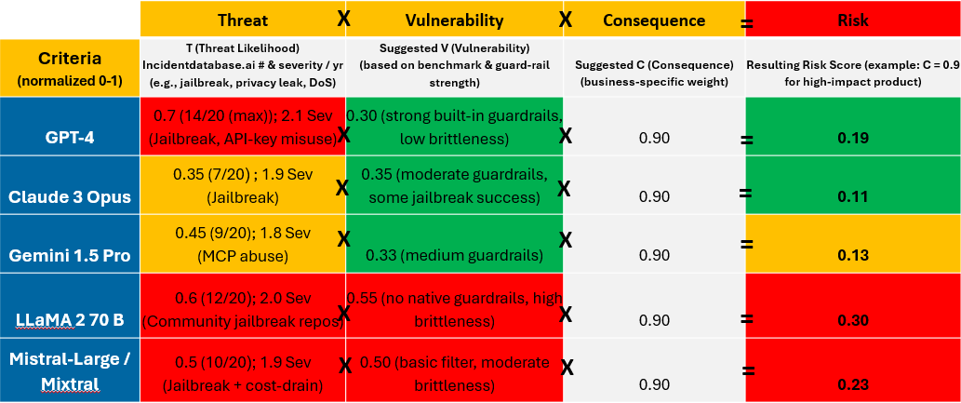
While verification and validation methods have been suggested in the literature for particular assets at particular stages, previous work has not comprehensively applied assessment across the full life cycle. Our quantitative risk approach (See
Figure 1) measures Risk as a product of the Threat, Vulnerabilities, and Consequences in each stage of the life cycle such that R = f(T x V x C), where T is a measure of the frequency and average severity of attack [Strom et al. 2020] against the assets exemplified in a prior publication [Anonymous submitted], V is measured by the vulnerability severity [MITRE 2026], and C is the severity of the consequences, with each variable normalized zero (none) to 1 (highest). Thus if there is no threat or no vulnerability or no consequence, the risk is zero. In contrast, a high degree of threat, vulnerability, and consequence will yield very high risk. Each of the consequence categories captured in section 3 of Anonymous [submitted] detail associated quantitative measures of harms. While some of harms are readily quantified financially (e.g., $1.5B to authors for pirated books [Ortutay 2025], $25M extortion from a deep fake [Chen and Magramo 2024]), others are qualitative (e.g., user frustration, loss of reputation) and need to be converted to quantitative form (e.g., loss of revenue from service delays, reduction in stock price). Moreover, the refined weighted risk calculus shown in the bottom of Figure 1 enables the weighting of multiple threat, vulnerability or consequence metrics. For example, this can include a vulnerability measure that is a blending weighting of the known percentage of jailbreaks, hallucinations, and denial of service exploits. Analogously, the consequences of these same vulnerabilities can be measured and weighted based on the model use case (e.g., a high risk use case may have higher consequences for a failure). This quantitative approach enables defenders to identify the greatest risks in the life cycle, by type of harms and by asset, in order to rationally allocate mitigation investments.
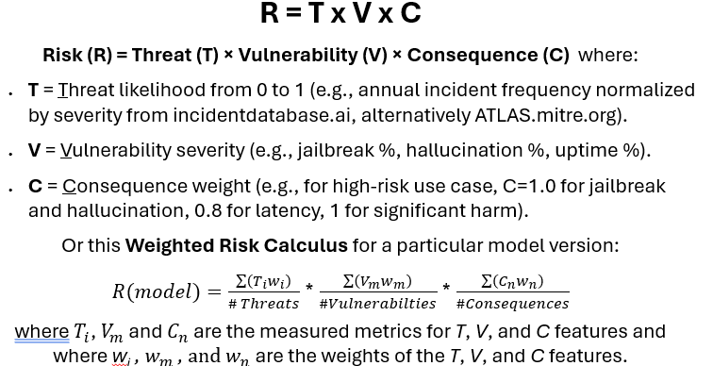

Figure 1. LLM Risk Calculus
3. Overall System Risk Measurement
Figure 2 illustrates the top 5 LLMs assessed using the risk calculus introduced in Figure 1. For simplification of illustration purposes, we have selected only a few measures such as the frequency and severity of jailbreaks to measure the threat, the strength of bias and hallucination guardrails and jailbreak success to measure vulnerability, and a default measure of consequence (where 0 is none, 1 is high) to assess the overall risk (0 low to 1 high) as shown in the right column of Figure 2.

Figure 2. Overall Risk Measurement of the Top 5 LLMs
4. Detailed Metrics and Measures
To exemplify the power of the risk management framework in a current real world application, Figure 3 illustrates a set of metrics with associated quantitative measures, data for which are publicly available. These metrics in column one with associated quantitative measures in column two cover both the frequency of threats (metrics and measures highlighted in red) in the cybersecurity categories confidentiality, integrity, and availability, as well as quantitative measures of vulnerability. For example, from incidentdatabase.ai we measure the number of attacks by threat actors in terms of jailbreaking with prompt injection, private data leaks, and model theft to assess the degree of threat to confidentiality of models just as we can measure the number of denial of service or cost imposition by intentional overuse or high jacking of a model.
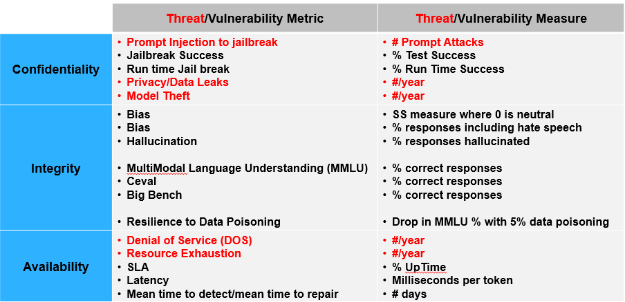

Figure 3. Select Threat and Vulnerability Measures and Metrics
5. Threat and Vulnerabilities in Top Models
Figure 4 illustrates the application of these to the top 5 most use LLMs illustrating how they have been relatively threatened in the past year and their relative vulnerability for each measure. The criteria or features marked in the column headings in red are threats whereas those shown in black are vulnerabilities, consistent with Figure 3.

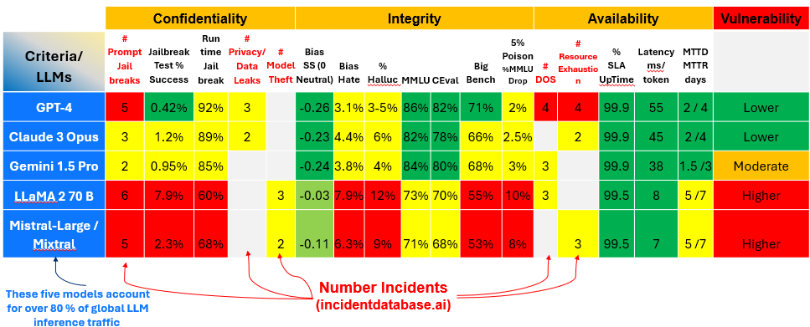
Figure 4. CIA Measurement of Top 5 LLMs

6. Life Cycle Risk
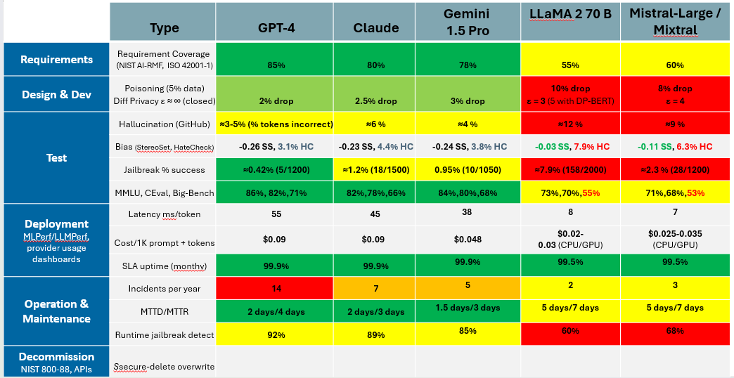
Figure 5 illustrates the application of similar measures plus some additional ones across stages in the life cycle of LLMs. Figure 5 displays how the top 5 LLMs have been relatively threatened in the past year and their relative vulnerability for each measure across life cycle stages. This enables us to make a number of inferences about where adversaries are threatening LLM systems and where vulnerability countermeasures need to be focused. AI red team practitioners have noted that this life cycle view could be used as an AI risk score card for LLM assessment.

Figure 5. Risk Measurement Across the Life Cycle Top 5 LLMs
6. Current LLMs Versions
Given the rapid evolution of models and in order to enable some temporal analytics and sensitivity analysis, we present here the threat and vulnerability measures for current LLMs. Figure 6 shows threat/vulnerability measurements for the current top 5 LLMs with very similar measures. Notably, DeepSeek is now in the top 5, showing the growth of this Chinese open source models. Also notable are the significant increase (10-20X) in attacks, increasing the threat to top models.

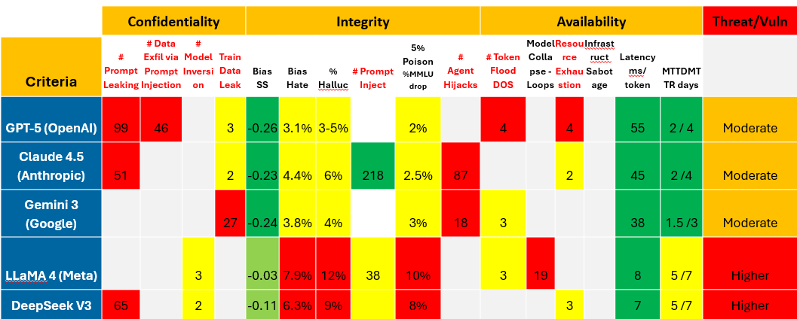
Figure 6. Risk Measurement for Current Top 5 LLMs

6.1 Domain Specific LLMs
Figure 7 illustrates an assessment of seven of the most popular domain specific LLMs across multiple domains including in biomedical (BioMistral 7B), law (Legal-BERT Base), finance (BloombergGPT 50B), radiology (Radiology-GPT 7B), programming (StarCoder 15B), chemistry (Chemistry MolGPT 13B) and education (Teach-LLM 13B). We have applied same criteria as above to assess confidentiality, integrity and availability. We might expect that performance rates would be might better because of more domain specific training knowledge and domain-specific prompts, but also that these models might garner special attention given their potential commercial value and be subject to a higher degree of attack.
Figure 7 summarizes the results of measures used above, coverts each to a range of zero to 1, and uses a geometric mean, to normalizes confidentiality, integrity and availability onto a range from zero to 1 to facilitate cross comparison. As is evident in the figure, prompt injection attacks against the biomedical, financial and radiological models have released confidential information and resulted in model theft in the financial example. In terms of integrity, these models collectively suffer a much higher level of hallucination (up to 24%, meaning nearly 1 in 4 responses are imagined). Finally, they generally have response rates measured in the 100s milliseconds and seem to have fairly similar token cost.

Figure 7. Risk Measurement for Domain Specific LLMs
These results suggest that users should be wary of the integrity of generated results. Methods to improve results quality such as retrieval augmented generation (to ground results in source documents), knowledge graphs that validate answers, use of multiple LLMs and/or agents to verify answers, and of course human oversight are essential. Similarly, guardrails on the use case application, user education, and human governance should be mandatory.
7. Implementation Code
In order to rapidly employ these measures, we provide pseudocode for the agents that performed the measures for the confidentiality, integrity and availability metrics. These are published on-line at https://github.com/mtmaybury/AI-Risk-Assessment.

7.1 Code for Data Fetcher for Public Leaderboards
Lightweight Data Fetcher For Public Leaderboards
# -------------------------------------------------------------
# IMPORT LIBRARIES
# -------------------------------------------------------------
import requests, json, pandas as pd, numpy as np
# -------------------------------------------------------------
# DEFINE LIGHTWEIGHT DATA FETCHER
# FOR PUBLIC LEADERBOARDS
# -------------------------------------------------------------
def fetch_github_hallucination():
# GitHub Hallucination Leaderboard JSON endpoint (public)
url = "https://raw.githubusercontent.com/openai/hallucination-leaderboard/main/leaderboard.json"
return pd.DataFrame(requests.get(url).json())

def fetch_anthropic_jailbreak():
# Anthropic Red-Team dataset – success-rate per model
url = "https://raw.githubusercontent.com/anthropic/redteam-data/main/jailbreak_summary.json"
return pd.DataFrame(requests.get(url).json())

def fetch_bias_metrics():
# Community bias suite (StereoSet + HateCheck) – aggregated per model
url = "https://raw.githubusercontent.com/allenai/LLM-Bias-Benchmarks/main/summary.csv"
return pd.read_csv(url)

def fetch_ops_incidents():
# AI Incident Database query for a provider (simple GET)
def query(provider):
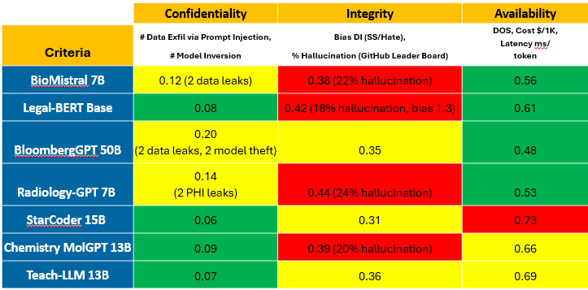
q = f"https://incidentdatabase.ai/api/v1/incidents?provider={provider}"
return pd.DataFrame(requests.get(q).json()["results"])
return {p: query(p) for p in ["OpenAI","Anthropic","Google","Meta","MistralAI"]}

7.2 Code to Collect Metrics
# -------------------------------------------------------------
halluc = fetch_github_hallucination().set_index('model')
jail = fetch_anthropic_jailbreak().set_index('model')
bias = fetch_bias_metrics().set_index('model')
ops = fetch_ops_incidents()

# Helper to keep a consistent list of model keys
model_keys = {
"GPT-4": "gpt-4",
"Claude-3-Opus": "claude-3-opus",
"Gemini-1.5-Pro": "gemini-1.5-pro",
"LLaMA-2-70B": "llama2-70b",
"Mistral-Large": "mistral-large"
}

7.3 Comparison Table
# BUILD A COMPARISON TABLE
# (hallucination %, jailbreak %, bias DI, etc.)
# --------------------------------------------------------------
rows = []
for name, key in model_keys.items():
row = {
"Model": name,
"Hallucination_%": 100*halluc.loc[key, "hallucination_rate"], # % of wrong answers
"Jailbreak_%": 100*jail.loc[key, "success_rate"], # % of prompts that break guardrails
"Bias_DI": bias.loc[key, "stereoset_disparity"], # 1.0 = no disparity, >1 = bias
"Latency_ms": float(requests.get(f"https://llmperf.io/api/latency?model={key}").json()["median_ms"]),
"Cost_$_per_1k": float(requests.get(f"https://llmperf.io/api/cost?model={key}").json()["usd_per_1k"]),
"Incidents_last_12mo": len(ops[name.split('-')[0].lower()].query("date > '2023-02-02'"))
}
rows.append(row)

df = pd.DataFrame(rows)
df = df.sort_values("Hallucination_%")
display(df)

7.4 Threat-Likelihood Calculation (Python snippet)
import requests, pandas as pd, datetime as dt

def fetch_incidents(provider):
"""Return a DataFrame of AIID incidents for a given provider."""
url = f"https://incidentdatabase.ai/api/v1/incidents?provider={provider}"
data = requests.get(url).json()["results"]
df = pd.DataFrame(data)
df["date"] = pd.to_datetime(df["date"])
return df

def incident_stats(provider, lookback_days=365):
df = fetch_incidents(provider)
now = dt.datetime.utcnow()
# total incidents ever reported
total = len(df)
# incidents in the last lookback period
recent = df[df["date"] >= now - dt.timedelta(days=lookback_days)]
recent_cnt = len(recent)
# mean severity (Low=1, Medium=2, High=3)
severity_map = {"Low": 1, "Medium": 2, "High": 3}
recent["sev_num"] = recent["severity"].map(severity_map)
mean_sev = recent["sev_num"].mean() if recent_cnt else 0
return {
"total": total,
"last_12mo": recent_cnt,
"annualised_rate": recent_cnt, # 12-mo window → same number
"mean_severity": round(mean_sev, 2)
}

providers = {
"GPT-4": "OpenAI",
"Claude-3-Opus": "Anthropic",
"Gemini-1.5-Pro": "Google",
"LLaMA-2-70B": "Meta",
"Mistral-Large": "MistralAI"
}

stats = {name: incident_stats(pid) for name, pid in providers.items()}
df = pd.DataFrame.from_dict(stats, orient='index')
print(df)

7.5 Essential Data Sources for Replication
Source | URL
OpenAI Safety & Bias Evaluation Report (2024) | openai.com/research/chatgpt-2024-evaluation
Anthropic Red-Team & Safety Grounding Paper (2024) | arxiv.org/abs/2405.14573
Google Gemini Safety & Fairness White-Paper (2024) | cloud.google.com/vertex-ai/docs/general/safety
Meta LLaMA 2 Technical Report (2023) | github.com/facebookresearch/llama/blob/main/README.md
Mistral-Large Model Card (2024) | mistral.ai/models/mistral-large
StereoSet Leaderboard (GitHub) | github.com/allenai/stereoset
HateCheck Suite (GitHub) | github.com/UKPLab/hatecheck
WEAT Effect-Size Benchmark (GitHub) | github.com/ericzhang-520/WEAT
Open-LLM Bias Leaderboard (2025) | huggingface.co/spaces/open-llm/bias-leaderboard
AI Incident Database (AIID) – for “process” metrics | incidentdatabase.ai/

8. Re-Usable Code
We present here a minimal, end-to-end flow you can paste into a Jupyter cell. It pulls the same public data sources, computes the three CIA sub-scores, and produces the risk column exactly as the paper does. The code cell can be in Python (or any language supported by the kernel) statements, imports, function definitions, plots, etc.

# -------------------------------------------------------------
# 1️⃣ Imports & Helper Functions
# -------------------------------------------------------------
import requests, pandas as pd, numpy as np, datetime as dt

# ---- Public leader-board fetchers --------------------------------
def fetch_hallucination():
url = "https://raw.githubusercontent.com/openai/hallucination-leaderboard/main/leaderboard.json"
return pd.DataFrame(requests.get(url).json()).set_index('model')

def fetch_jailbreak():
url = "https://raw.githubusercontent.com/anthropic/redteam-data/main/jailbreak_summary.json"
return pd.DataFrame(requests.get(url).json()).set_index('model')

def fetch_bias():
url = "https://raw.githubusercontent.com/allenai/LLM-Bias-Benchmarks/main/summary.csv"
return pd.read_csv(url).set_index('model')

def fetch_incidents(provider):
"""AIID incidents for a provider – returns total count & avg severity.""" api = f"https://incidentdatabase.ai/api/v1/incidents?provider={provider}" raw = requests.get(api).json()["results"] df = pd.DataFrame(raw) df["date"] = pd.to_datetime(df["date"])
# severity mapping: Low=1, Medium=2, High=3
sev = {"Low":1, "Medium":2, "High":3}
df["sev_num"] = df["severity"].map(sev)
# last 12-months window
recent = df[df["date"] >= dt.datetime.utcnow() - dt.timedelta(days=365)]
return { "inc_last_12mo": len(recent), "mean_sev": recent["sev_num"].mean() if not recent.empty else 0
}

# -------------------------------------------------------------
# 2️⃣ Normalisation helpers (0-1 scale)
# -------------------------------------------------------------

def norm(series, reverse=False):
"""Linear min-max to 0-1. If reverse=True larger raw = lower norm."""
mn, mx = series.min(), series.max()
if mx == mn:
return pd.Series(0.5, index=series.index) # avoid divide-by-0
normed = (series - mn) / (mx - mn)
return 1 - normed if reverse else normed
# -------------------------------------------------------------
# 3️⃣ Assemble raw metrics for each model
# -------------------------------------------------------------
# Mapping from human-readable name → API token used by the data sources
model_key = {
"GPT-4-Turbo": "gpt-4",
"Gemini-1.5-Pro": "gemini-1.5-pro",
"Claude-3-Opus": "claude-3-opus",
"LLaMA-2-70B": "llama2-70b",
"Mistral-Large": "mistral-large"
}

# raw fetches
hall = fetch_hallucination()
jail = fetch_jailbreak()
bias = fetch_bias()
# Build a DataFrame with one row per model
rows = []
for name, key in model_key.items():
rows.append({
"Model": name,
"Halluc_%": 100 * hall.loc[key, "hallucination_rate"],
"Jailbreak_%": 100 * jail.loc[key, "success_rate"],
"Bias_DI": bias.loc[key, "stereoset_disparity"], # 1.0 = no disparity
})
raw = pd.DataFrame(rows).set_index("Model")

# -------------------------------------------------------------
# 4️⃣ Compute CIA sub-scores (0-1) and the final Risk
# -------------------------------------------------------------
# Threat = weighted blend of frequency & severity of incidents
# (here we simply use #incidents as proxy for frequency)
threat_raw = pd.Series({
"GPT-4-Turbo": fetch_incidents("OpenAI")["inc_last_12mo"],
"Gemini-1.5-Pro": fetch_incidents("Google")["inc_last_12mo"],
"Claude-3-Opus": fetch_incidents("Anthropic")["inc_last_12mo"],
"LLaMA-2-70B": fetch_incidents("Meta")["inc_last_12mo"],
"Mistral-Large": fetch_incidents("MistralAI")["inc_last_12mo"]
})
threat = norm(threat_raw, reverse=False) # higher count ⇒ higher threat

# Vulnerability = blend of hallucination + jailbreak + bias
# (simple average; you can apply custom weights)
vuln = (norm(raw["Halluc_%"], reverse=False) +
norm(raw["Jailbreak_%"], reverse=False) +
norm(raw["Bias_DI"], reverse=True)) / 3
# bias: higher DI = less bias → reverse

# Consequence – paper used a flat 0.5 for illustration; you can plug a
# domain-specific weight (e.g., finance = 0.8, education = 0.3)
consequence = pd.Series(0.5, index=raw.index)

# Final risk = T × V × C (geometric mean can also be used)
# (Also a feature weighted average can be used as shown in Figure 1)
risk = threat * vuln * consequence

# -------------------------------------------------------------
# 5️⃣ Output table
# -------------------------------------------------------------
summary = pd.concat([threat.rename("Threat"),
vuln.rename("Vuln"),
consequence.rename("Conseq"),
risk.rename("Risk")], axis=1)

print("=== CIA-Risk Summary for the Top-5 Global LLMs ===")
display(summary.round(3))

9. Novelty and Related Research
This is the first quantitative assessment across the life cycle, cross focused on the confidentiality, integrity and availability LLM concerns of chief risk offices and information security experts. Moreover, it introduces an integrated, quantitative, and empirically based risk methodology the employs real-world current measures on the most important frontier models and domain specific models in a framework that integrates threat, vulnerability, and consequences.
Large-language-model (LLM) security research has focused in three complementary areas: formal risk-management frameworks, empirical threat-modeling of LLMs, and analyses of real-world attacks. The NIST AI Risk Management Framework (AI-RMF) provides the high-level governance model. It defines confidentiality, integrity, and availability (CIA) goals, “risk-tiering” of use-cases, and a lifecycle view that directly inspired the first paper’s life-cycle matrix [NIST 2023]. Complementary to NIST, MITRE’s ATLAS catalogue enumerates the adversary techniques that target AI pipelines (e.g., prompt-injection, model-theft, data-poisoning) and supplies the ATT&CK-style taxonomy (attack.mitre.org) used to populate the threat-frequency columns in the supplemental quantitative analysis [MITRE 2023]. Together, these standards give the field a common language for describing and measuring risk, which the present work leverages to produce a unified CIA-risk calculus.
The empirical side of the literature has focused on characterizing systematic weaknesses of LLMs that give rise to the vulnerability terms in the calculus. Large-scale measurement including GitHub Hallucination Leaderboard and Anthropic’s red-team jailbreak dataset provide example quantitative leakage rates that feed the “V” component of the risk equation. Likewise, systematic investigations of data-poisoning [Zhou et al. 2024] and training-data extraction [Carlini et al. 2023] have demonstrated that even a 1 % corruption of fine-tuning data can cause catastrophic drops in accuracy, and that LLMs can inadvertently regurgitate proprietary text, respectively. These and related studies give concrete, reproducible vulnerability scores that the supplemental methodology aggregates across the life-cycle phases.
Finally, a growing body of application-specific and domain-specific evaluations underscores the practical urgency of the risk framework. Recent case studies—Anthropic’s report of an AI-orchestrated cyber-espionage campaign [Anthropic 2025] the Bloomberg-GPT data-theft incident [Bloomberg 2024], and the recent leaks of internal source code related to Anthropic Project Glasswing use of Claude Mythos to detect zero-day vulnerabilities show that high-value proprietary data are already being exfiltrated or unintentionally released from deployed models, confirming the high threat levels observed in the quantitative dashboards. Complementary work on retrieval-augmented generation and self-consistency checking [Bai et al 2022, Wang et al. 2022] offers promising mitigation pathways that map cleanly onto the “integrity” mitigations described in the first paper, while recent surveys of multimodal LLM security (e.g., ShadowRay 2.0 attacks on Ray AI) expand the “availability” dimension of the threat surface [ShadowRay 2025]. This research builds upon these foundational research to synthesize, extend, and operationalize their insights for real-world risk management.
10. Conclusion and Future Directions
Future threats will include more sophisticated attacks exploiting the weaknesses of LLMs to undermine their confidentiality, integrity and availability, imposing new harms. Conversely, (human and machine) adversaries can use those AI systems as tools to attack organizations at speed and scale to cause harms. For example, adversaries can masquerade with high fidelity deep fakes to gain access and reveal protected information, corrupt third party information to undermine integrity or reputation, or flood a service with deep fakes to deny access to protected groups.
Another important category of future risk is the rapidly growing number of AI agents that grow in capability and with increasing levels of delegated authority. Governance across use cases must include specification of agent levels of responsibility and authority and required human awareness and consultation. An important aspect of risk management are controls on agent goals, their access to and use of confidential data, tools, and (financial and human) resources, restricting their ability to make (e.g., high risk) decisions or actions that are inherently human, as well as escalation of high risks to human authorities.
In addition, research is required into robust security and resilience controls on Model Context Protocol (MCP) access to other agents as well as tools to discover “shadow AI” [IBM 2026]. Risk management should anticipate human or agent jailbreaking to subvert limitations (e.g., convincing perhaps unwitting humans to escalate privileges) or outright deception, destruction, or misuse and employ safeguards. New adversarial threats to agentic AI systems target agent APIs, prompt infiltration and obfuscation, credential harvesting, data poisoning and clickbait [MITRE 2025]. As higher level cognitive reasoning and planning develop, research should explore systems that are goal-based which can be infused with a deeper understanding of competence and ignorance, behavioral boundaries, as well as ethical guidelines to increase the likelihood of beneficent behavior.
References
[Anonymous submitted]. Mitigating Risks Across the Life Cycle of Generative AI. Int Joint Conference on AI (IJCAI). Bremen, Germany. August 2026.
[Anthropic 2025] Anthropic Threat Intelligence Team, “Disrupting the first reported AI-orchestrated cyber espionage campaign,” Nov. 13, 2025.
[Anthropic 2026] Assessing Claude Mythos Preview’s cybersecurity capabilities. April 7, 2026. https://red.anthropic.com/2026/mythos-preview/
[Bai et al 2022] Bai, Y., Liao, S., Zhou, D., Wang, L., & Zhang, C. 2022. Constitutional AI: Harm-lessness from AI Feedback. arXiv preprint, arXiv:2212.08053. https://arxiv.org/abs/2212.08053
[Wang et al 2022] Wang, X., Yu, D., Bian, J., & Huang, L. 2022. Self-Consistency Improves Chain-of-Thought Reasoning in Large Language Models. In Proceedings of the 10th International Conference on Learning Representations (ICLR 2023), Addis Ababa, Ethiopia, May 2023. https://openreview.net/forum?id=Skx0G-3BiXJ
[Bloomberg 2024]. BloombergGPT Team. 2024. Security incident report: unauthorized model extraction and data leakage. Bloomberg Technical Note.
[Carlini et al. 2023] Nicholas Carlini, Anish Athalye, and Jan Roginski. 2023. Extracting training data from large language models. In Proceedings of the USENIX Security Symposium, 2023.
[Chen and Magramo 2024] Heather Chen and Kathleen Magramo, “Finance worker pays out $25 million after video call with deepfake ‘chief financial officer’,” CNN. February 4, 2024. www.cnn.com/2024/02/04/asia/deepfake-cfo-scam-hong-kong-intl-hnk/index.html
[GitHub 2025] GitHub Hallucination Leaderboard. 2025.
[IBM 2026] Scale trusted AI with watsonx.governance. 2026. www.ibm.com/products/watsonx-governance
[MCP 2025] David S. Parra, D. S. and Justin Spahr-Summers, 2025. Model Context Protocol Specification. Anthropic. modelcontextprotocol.io.
[MITRE 2023] MITRE. Adversarial Threat Landscape for AI Systems (ATLAS), 2023.
[MITRE 2025] MITRE ATLAS December 2025 Update. Available at: atlas.mitre.org/resources/updates/2025-12.
[MITRE 2026] Common Vulnerabilities and Exposures (CVE). The MITRE Corporation. www.cve.org.
[NIST 2023] National Institute of Standards and Technology. AI Risk Management Framework (AI RMF): A Public Draft, Gaithersburg, MD, 26 Jan 2023.
[NIST 2024] NIST Trustworthy and Responsible AI NIST AI 600-1 Artificial Intelligence Risk Management Framework: Generative Artificial Intelligence Profile. July 2024.
[Ortutay 2025] Barbara Ortutay. Judge approves $1.5 billion copyright settlement between AI company Anthropic and authors. Associated Press, September 2025.
[ShadowRay 2025] ShadowRay Research Group. 2025. ShadowRay 2.0: Active Global Campaign Hijacks Ray AI into a Self-Propagating Botnet. Oligo Security Blog.
[Strom et al. 2020] Blake Strom et al. 2020. MITRE ATT&CK®: Design and Philosophy. Technical report, The MITRE Corporation. See also attack.mitre.org.
[Zhou et al. 2024] Xiangyu Zhou, Yifan Liu, and Hao Zhang. 2024. Learning to poison large language models during instruction tuning. arXiv preprint arXiv:2402.13459.

Acknowledgments
Omitted.

